Capstone 0 — Instructor / Course Use Case

Intelligent Service Desk Orchestrator (ISDO)
Role in the program: This is the spine of the training. A slice of it is built or demonstrated in every lab, every day. By the end of Day 5 the class has watched one coherent system grow from a single prompt into a full multi-agent, MCP-connected, A2A-enabled service desk.
Audience fit: BizOps / Service Delivery / VMO functional experts (basic Python) | Tools: Claude Desktop, GitHub Copilot, LangChain/LangGraph, Python | Approach: Vibe-coding (describe intent → Copilot scaffolds → participants steer & validate)

The Business Problem (detailed)

Zensar operates managed service desks that absorb large daily volumes of IT support tickets across email, portal, and chat. The recurring pain is not the hard tickets — it is the predictable middle:

Triage drag. L1 agents spend the first 3–5 minutes of every ticket re-reading, categorising, and guessing priority. Misclassification pushes tickets to the wrong queue, adding hours of bounce- back.
Knowledge that exists but isn't reached. 40–60% of inbound tickets are "seen before" — password resets, VPN failures, known app errors — yet the matching KB article is rarely surfaced at intake.
SLA surprises. Breaches are noticed after they happen, not predicted before. Escalations are manual and inconsistent.
Communication tax. Requesters chase updates because nobody proactively tells them where their ticket stands.

The target the course sets — 60–70% automation of the repeatable workflow — is realistic precisely for this middle band. The ISDO demonstrates an agentic system that ingests a ticket, understands it, resolves or routes it, watches its SLA, and keeps the requester informed — with a human approving anything risky.

Why agentic (not RPA): the work requires reading unstructured text, reasoning over context, choosing tools, and adapting — exactly where rule-based RPA stalls and an agent loop (Perceive → Reason → Act → Reflect) shines. This is the live answer to the course's "agents vs. RPA" discussion.

Objective

Build an end-to-end, human-supervised agentic system that manages an IT support ticket across its full lifecycle, integrating with ServiceNow- and Jira-style systems through a custom MCP server, coordinating specialist agents via A2A, and enforcing Responsible-AI guardrails.

ITSM Lifecycle Covered

Stage | What the system does
Intake & summarise | Normalise ticket text from portal/email; produce a clean summary
Triage | Classify category, predict priority/severity, detect PII
Route / assign | Map to the correct queue/team in ServiceNow or Jira
Resolve | Retrieve matching KB articles; draft a resolution or auto-resolve L1 items
SLA & escalate | Predict breach risk; raise escalation with HITL approval
Communicate | Draft requester-facing status updates and resolution notes
Close & learn | Log decisions, capture CSAT prompt, feed quality signals back

- Target Architecture

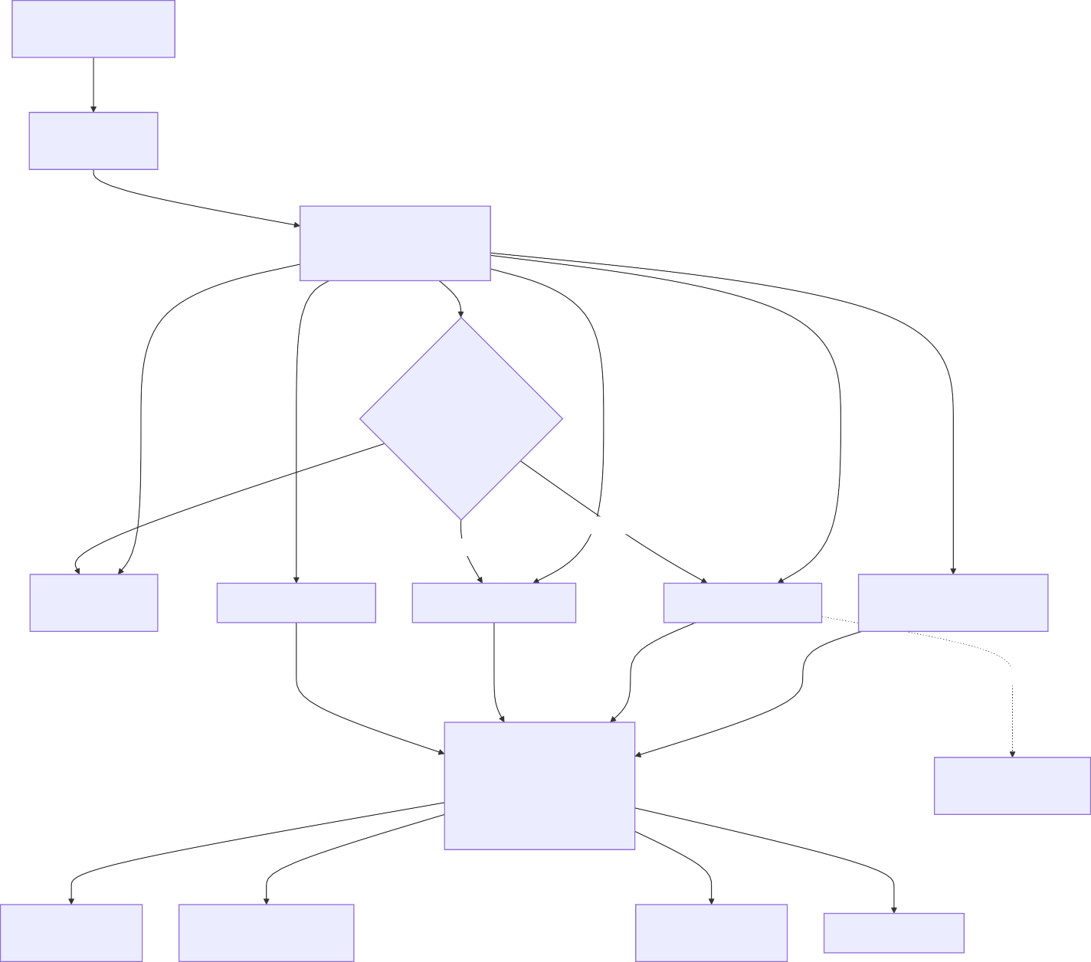Requester (portal / email / chat)

Supervisor / Orchestrator Agent
Responsible-AI Layer

PII Redaction & Input Guardrails

Audit Log (every decision)
(LangGraph StateGraph)

HITL Approval Gate access grant · P1 escalation

approved
approved

Communication Agent

SLA & Escalation Agent

Resolution / KB Agent
Triage Agent classify · priority · category

A2A call

Knowledge Specialist (separate A2A server)
Custom MCP Server (Python)

MCP Tools get_open_tickets · classify_ticket get_sla_status · update_ticket
search_kb · post_comment

ServiceNow (mock REST / CSV)
Jira Service Management (mock REST / CSV)
Knowledge Base (files / vector store)

CMDB / Asset data

Agent roster

Agent | Responsibility | Key tools
Supervisor | Owns the workflow graph, routes work, holds state | — (orchestration)
Triage | Classify, prioritise, flag PII | classify_ticket ,  get_open_tickets
Resolution / KB | Find fix, draft resolution, auto- resolve L1 | search_kb , A2A → Knowledge Specialist
SLA & Escalation | Predict breach, raise escalation | get_sla_status ,  update_ticket

Agent | Responsibility | Key tools
Communication | Draft requester updates & closure notes | post_comment
Knowledge Specialist  (remote, via A2A) | Deep KB / past-incident lookup, exposed as an independent agent | own MCP/data

Lab-by-Lab Build Map (the threading)

This is what makes ISDO the course use case — each "Instructor demo" slot in your outline gets a concrete deliverable.

Day / Lab | Module focus | ISDO increment demonstrated
Lab 1.1 | First agent interaction | Structured prompt that summarises a raw ticket
Lab 1.2 | Prompt & spec engineering | Prompt templates for triage; an agent spec for the Triage Agent
Lab 2.1 | Single agent (LangChain) | Triage Agent with file-reader + search over a sample ticket CSV
Lab 2.2 | Data connectivity + HITL | Connect to Excel/CSV ticket data; add HITL gate on access-grant / escalation
Lab 3.1 | Use existing MCP server | Pull KB articles via a filesystem/search MCP server in Claude Desktop
Lab 3.2 | Build custom MCP server | ServiceNow/Jira MCP server exposing get_open_tickets ,  get_sla_status , update_ticket
Lab 4.1 | Multi-agent orchestration | Triage → Communication 2-agent LangGraph handoff
Lab 4.2 | A2A protocol | Resolution Agent calls the Knowledge Specialist via A2A  (Agent Card + task round-trip)
Lab 5.1 | Full integration | End-to-end ISDO: orchestration + MCP + A2A + HITL gate

Day / Lab | Module focus | ISDO increment demonstrated
Lab 5.2 | Retrospective | Design-decision walkthrough: what to reprompt vs. retool vs. redesign

Data Sources (classroom-safe)

Mock ServiceNow export — incidents.csv (number, short_description, description, category, priority, assignment_group, sla_due, state).
Mock Jira SM export — requests.csv (key, summary, request_type, priority, assignee, sla, status).
Mock REST shims — tiny Python/Flask endpoints mimicking ServiceNow Table API and Jira REST so the MCP server calls feel real without touching production.
KB corpus — a folder of markdown articles + an optional local vector store.

No live credentials. All systems are mocked — this is also the platform-mandate lesson (see §8).

Topic Coverage Matrix (proves full-course coverage)

Course topic | Where ISDO exercises it
AI vs GenAI vs Agentic; agent loop | Triage Agent embodies Perceive→Reason→Act→Reflect
Agent taxonomy & patterns; agents vs RPA | Supervisor-specialist pattern; RPA-vs-agent contrast in §1
Prompt engineering | Lab 1.1/1.2 ticket-summary & triage prompts
Context & spec engineering | Triage Agent spec; feeding ticket + KB context
Agent anatomy; LangChain | Lab 2.1 single Triage Agent
Tools & tool calling | MCP tools + file reader + search
Data connectivity (CSV / ServiceNow / Jira REST) | Lab 2.2 + 3.2

Course topic | Where ISDO exercises it
HITL design | Access-grant / P1 escalation gate
MCP — use existing | Lab 3.1 filesystem/search server
MCP — build custom + connect to system | Lab 3.2 ServiceNow/Jira MCP server
Multi-agent + LangGraph orchestration | Lab 4.1 + 5.1 StateGraph
A2A protocol (Agent Card, Task, lifecycle, streaming) | Lab 4.2 Knowledge Specialist
Integration (MCP + A2A + multi-agent) | Lab 5.1
Responsible AI (PII, guardrails, audit, compliance) | §8 + guardrail layer
Maintenance (monitor, feedback, versioning) | Lab 5.2 retrospective
Use-case mapping | Anchors the Lab 5.2 framework

- Responsible AI, PII & Platform Mandates

PII redaction before the LLM. Names, emails, employee IDs, IP addresses are masked at the guardrail layer; the un-redacted record stays in the system of record only.
What enters context. Only the fields an agent needs (short_description, category, SLA) — never full HR/financial payloads.
Audit trail. Every classification, tool call, and approval is logged with timestamp, agent, and rationale — the basis for review and rollback.
Access control & data residency. Mock connectors stand in for the real constraint: agents run inside the client's boundary, no data leaves approved regions.
Platform mandate framing. Because Zensar engagements often mandate the client's own LLM endpoint and tooling, the system is built so the model backbone and connectors are swappable
— the architecture is the deliverable, not a specific vendor.

Deliverables & Evaluation (for the instructor demo)

Deliverables: working ISDO repo (incremental, lab-tagged), the MCP server, the A2A Knowledge Specialist, sample data, and this brief as the reference spec.
What "good" looks like: correct triage on held-out tickets, a clean HITL pause/resume, a successful A2A round-trip, redaction visible in logs, and a coherent end-to-end run in Lab 5.1.

